|  |
| --- |
| 2.4 Acres |
| Hwy 278  Covington, GA |

$2,500,000.00

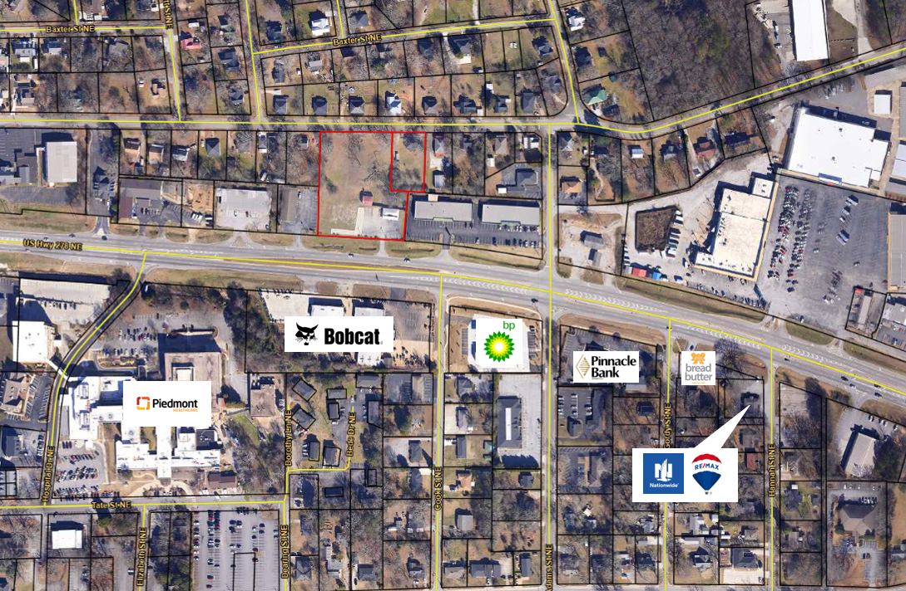

**2.4 ac.**

- 280 ft of frontage on Hwy 278

- 326 ft of frontage on Wheat St

- All Utilities

- 1.93 acres zoned: Corridor Mixed-Use

- .44 acres zoned NR-2

Property Features:

**NR-2**

**CM**

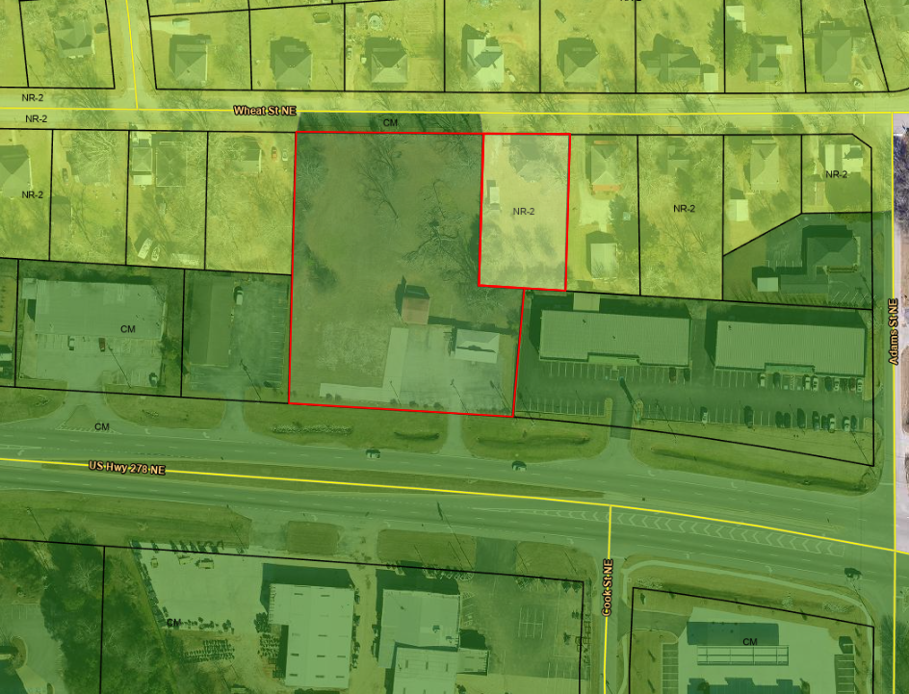

**NR-2**

**CM**

**EXIT 92**

**EXIT 90**

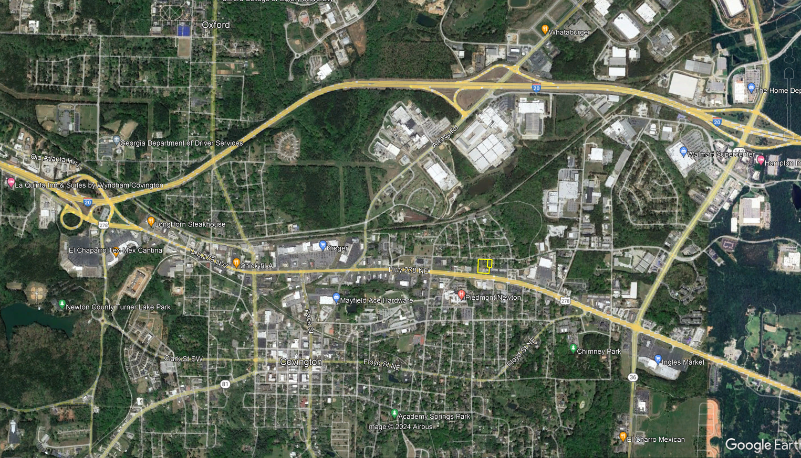

David Hays

The Mansfield Group

404.308.1846

[dawgs74hays@yahoo.com](mailto:dawgs74hays@yahoo.com)

CONTACT INFORMATION: